List of Required Documents for Residence Permit (for work purpose) Application

- Original of the applicant’s physical examination record issued by the International Travel Healthcare Center in Shantou: 3 photos in blue background and original of passport are required when taking the physical examination in the center with the address: 1/F, Entry-Exit Inspection and Quarantine Bureau, No.126 Jinsha Road, Longhu District, Shantou, Guangdong Province, P.R.China (中国广东省汕头市龙湖区金砂东路126号出入境检验检疫大楼1楼) and phone number: +86 754 8854 8004.
- Photo of the applicant with blue background and a size of 2 inches and Receipt of China Visa Photograph for Foreigners in Guangdong Province (see sample in Appendix 2);

The following documents are prepared by International Office:
- Completed, signed and stamped Visa / Stay Permit / Residence Permit Form (see sample in Appendix 1);
- Original and photocopy of the applicant’s passport, current visa / residence permit and latest entry stamp page;
- Original of the Registration Form of Temporary Residence for Visitors issued by the local police station after the applicant’s police registration;
- Original of an application letter issued by the International Office of Shantou University;
- Original and photocopy of the applicant’s work permit;

Appendix

Appendix 1:
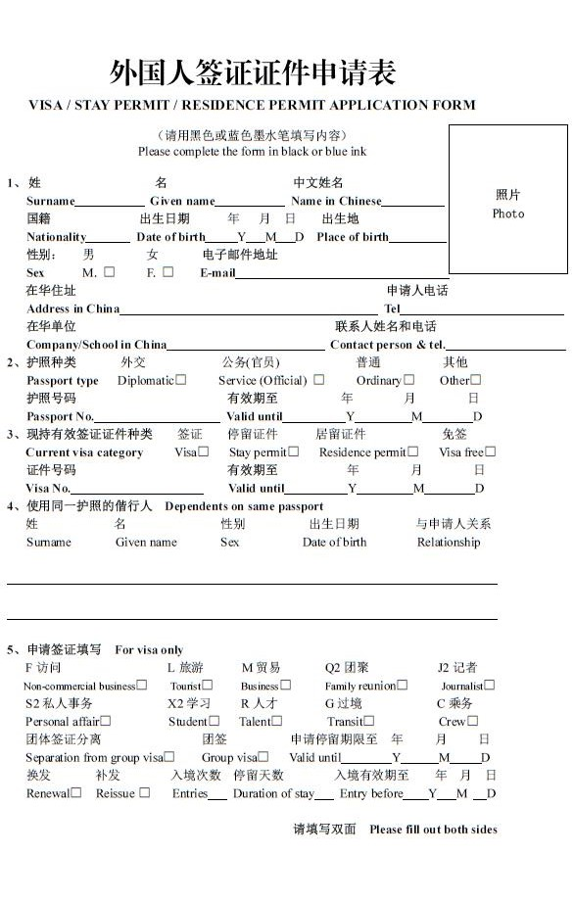
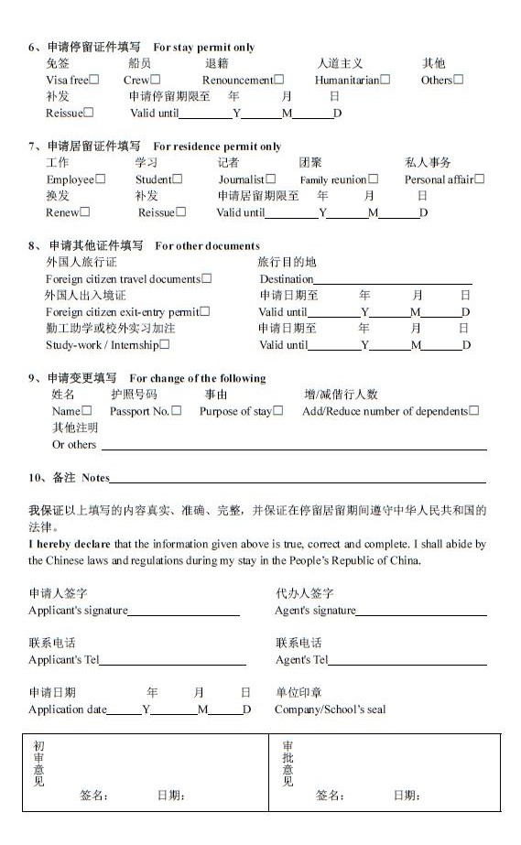
Appendix 2:
Receipt of China Visa Photograph for Foreigners in Guangdong Province
